Prototipado Garban

Daniel Segura
Johan Sastoque

Edwin Alexander
CEET
Bogotá D.C
06/04/2026

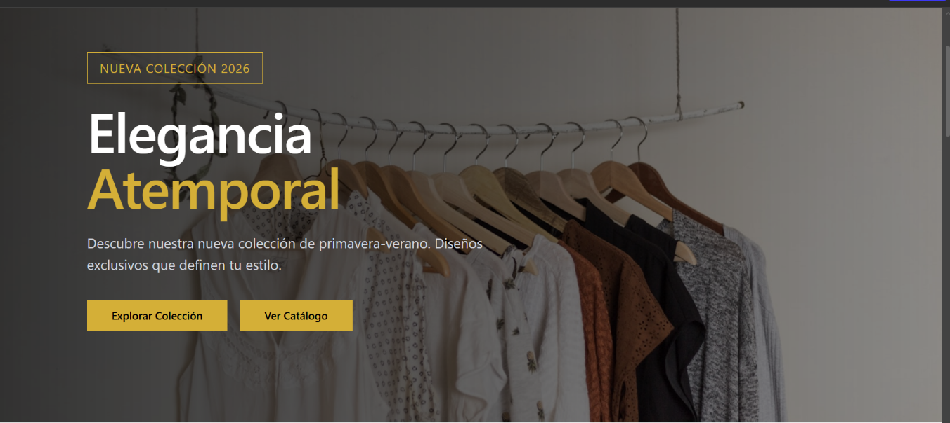

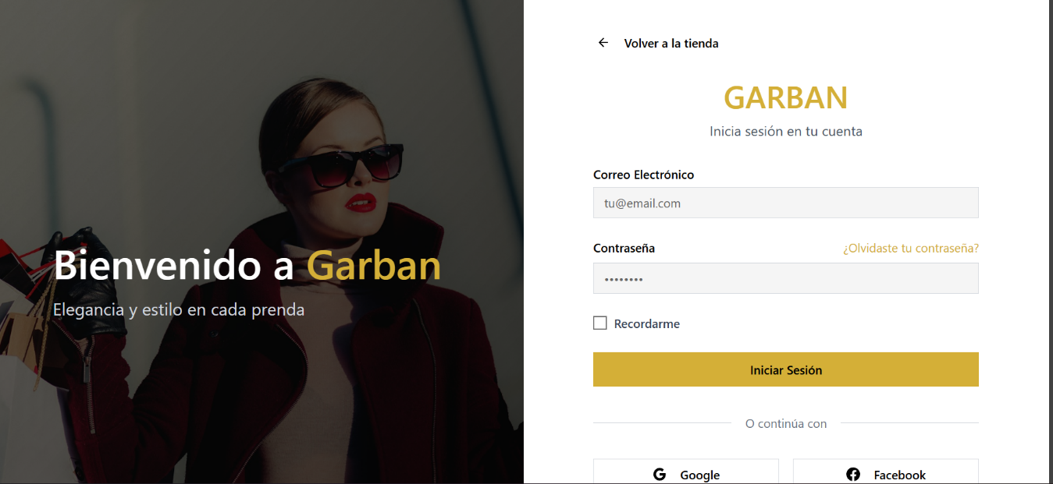

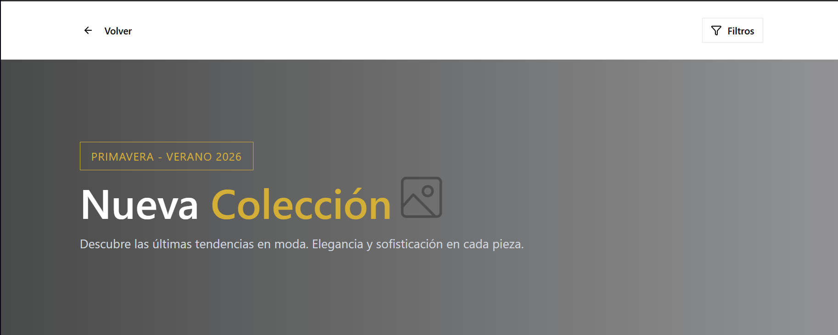
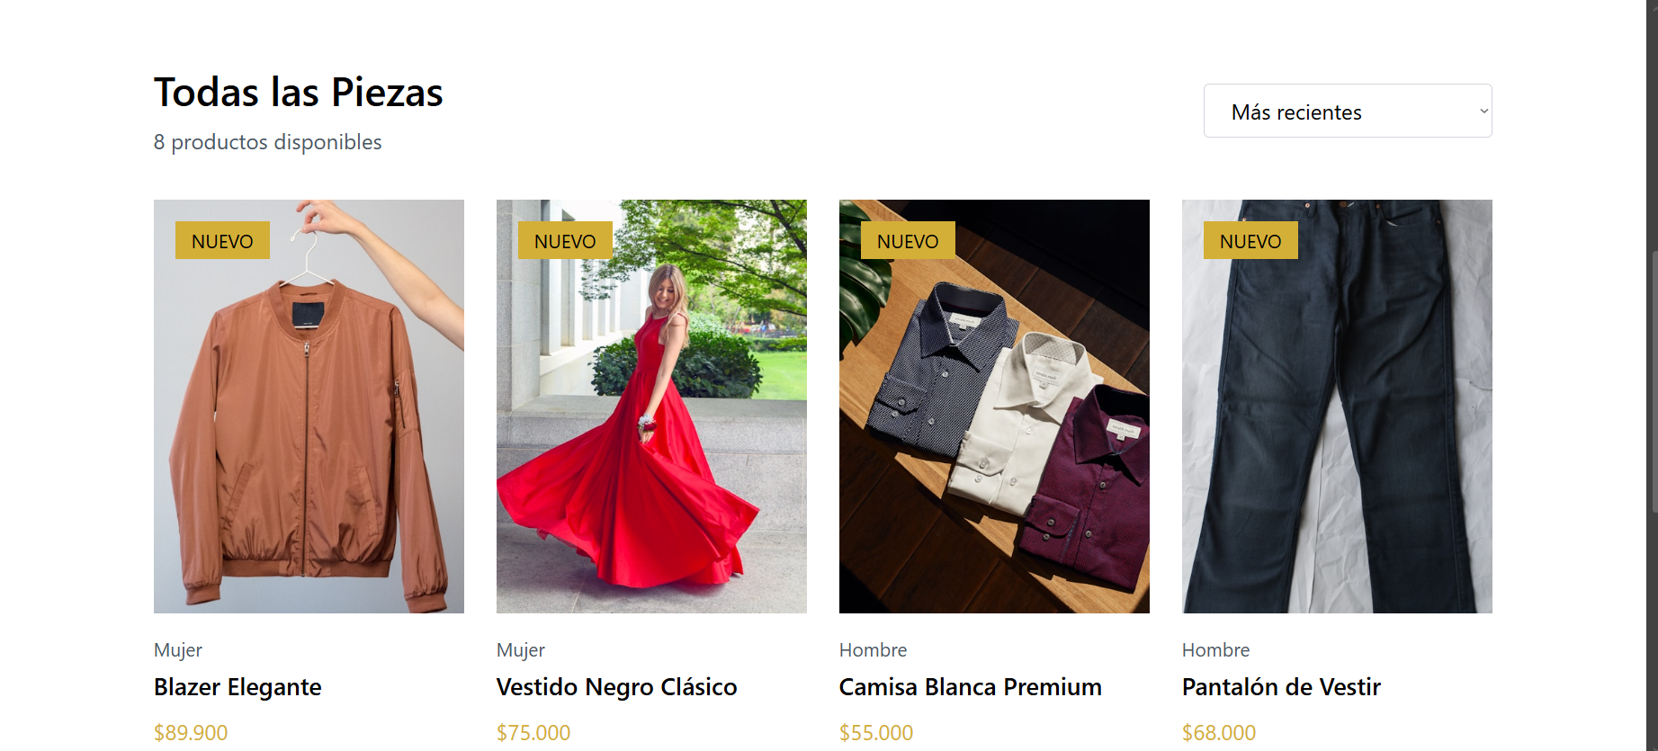



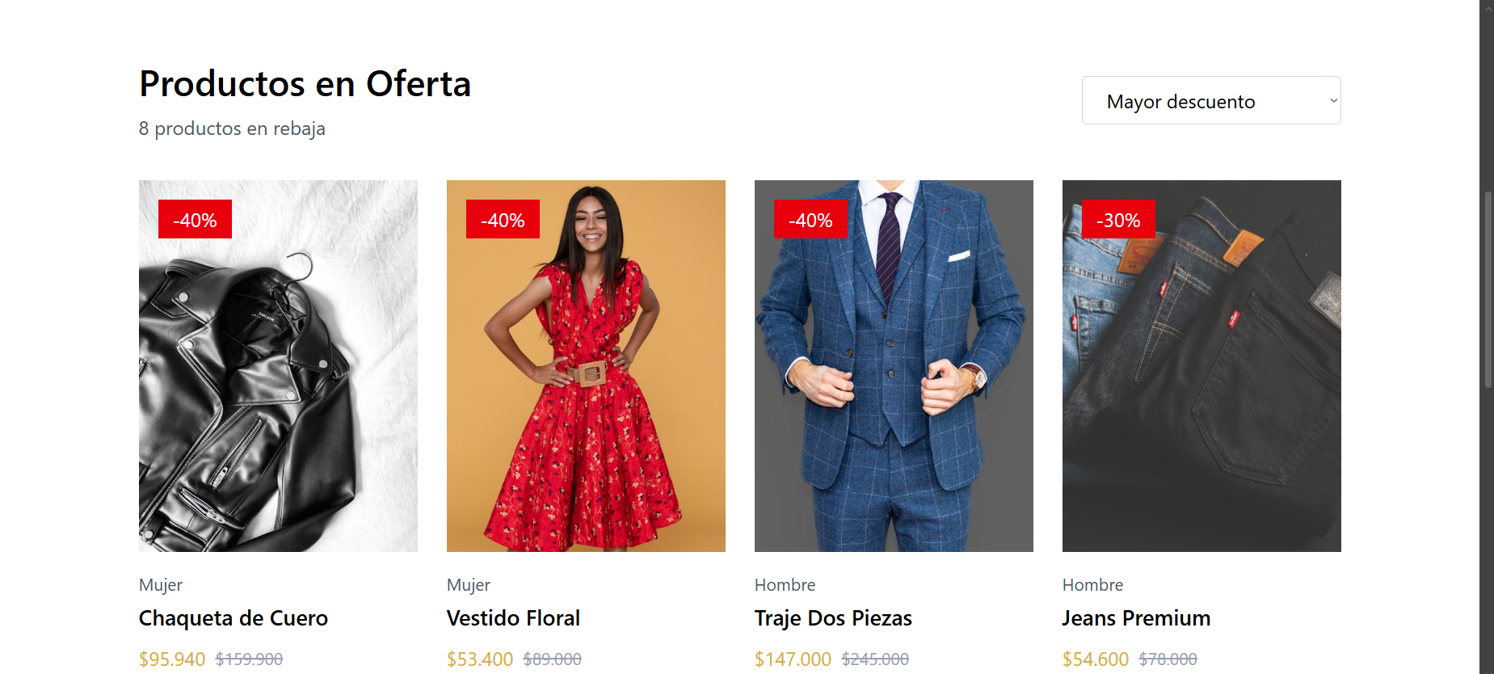


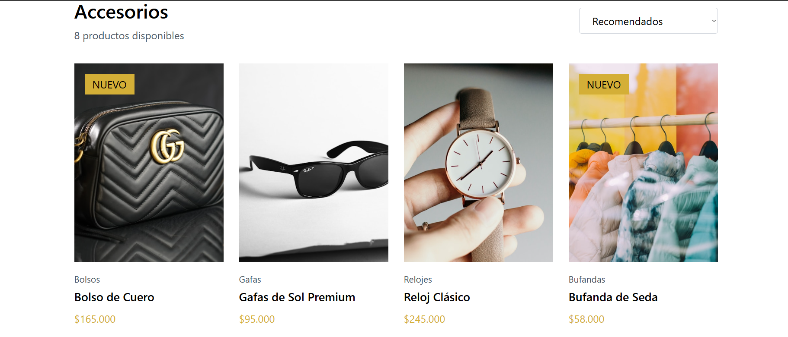

LINK Figma:https://www.figma.com/make/wfyMt5WX3siSmssu9QUciN/Crear-maquetaci%C3%B3n-del-proyecto?t=TzZzkeqbiIFxnPld-20&fullscreen=1

